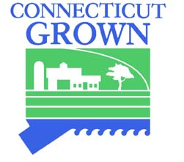
GLASTONBURY FARMERS MARKET
COALITION, INC.

2019 MARKET SPONSORSHIP OPPORTUNITIES

The Glastonbury Farmers Market connects the Glastonbury community to local farmers, providing farm fresh, sustainably grown or raised products. The Market also showcases the best in baked goods and artisanal products, and provides an opportunity to support local businesses, musicians, and artists.

We invite you to join us in promoting locally grown, fresh, quality produce and artisan products.

- $250 Level – SAGE
  - Name and logo on GFM website
  - Name and logo on GFM Facebook page
  - Name and logo displayed each Market Day
  - Booth available for three Market Days

- $500 Level – ROSEMARY
  - Name and logo on GFM website
  - Name and logo on GFM Facebook page
  - Name and logo displayed each Market Day
  - Booth available for six Market Days

- $1000 Level – PLATINUM
  - Name and logo on GFM website
  - Name and logo on GFM Facebook page
  - Name and logo prominently displayed on sponsor banner each Market Day
  - Booth available each Market Day

Name _________________________________ Phone ___________________________

Business Name _________________________ Email ____________________________

Website ___________________________________________________________________

Mailing Address _____________________________________________________________

Glastonbury Farmer’s Market Coalition, Inc.
P. O. Box 554, South Glastonbury, CT 06073
glastonburyfarmersmarket@gmail.com

